THEN AND NOW PROMPT DECEMBER 2024
CHRISTMAS
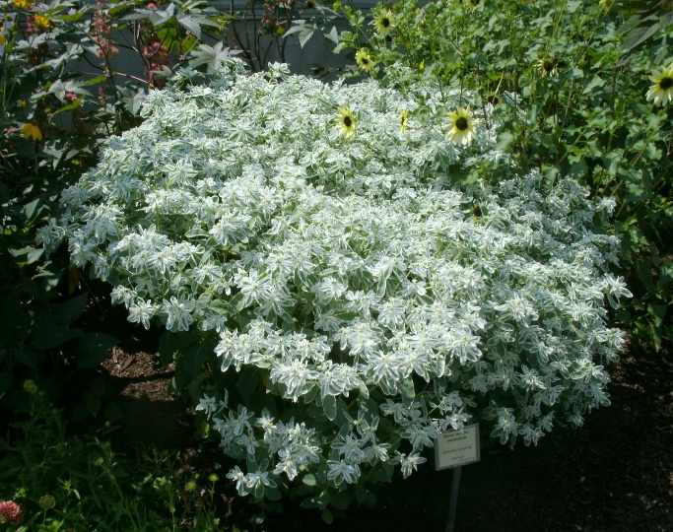
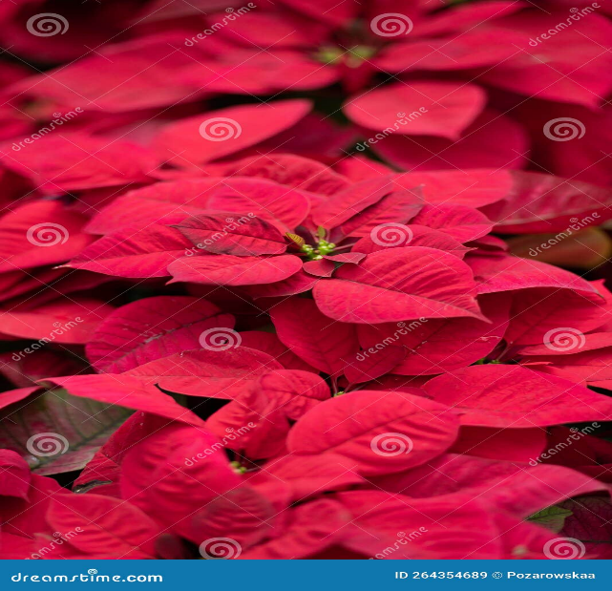
When the white flowers of a wild shrub, bitter bush, appeared, then the leaves of Euphorbia, or snow in the mountain, begin to turn white, and the green leaves of the poinsettia, with which it was often planted, change to red, my heart filled with joy and excitement. Christmas was fast approaching. Shortly, the surroundings would be ablaze with this spectacular show of colours

Christmas traditions would begin in our home. My Dad arranged painting of the house and surroundings. The lower two feet of trees around the yard, curb walls and garden rocks were painted with whitewash, a solution of water and lime from the lime-kiln my father had burned, some months earlier.
Then Mum, and my older sisters, hung new drapes and curtains, they had either purchased or made.
We also baked Christmas fruit cakes, for home consumption, gifts, and to serve to guests who visited us during the holiday season.
One highlight for me was going to Grand Market in the city of Mandeville, with my older siblings and some of their friends, on Christmas Eve night. There, we strolled through the bright, twinkling lights of the capital, greeting friends whom we encountered. The street vendors were still out, and some stores remained open. This proved convenient for those who had not yet completed their shopping.
My treats included ice cream cones, crunchy American apples, unlike our local soft-textured red Otaheite apples, sweets, and chocolates. A cold bottled pineapple soda was my favourite drink. Even today, I occasionally indulge in that soda, just to experience the nostalgia of those earlier years. The siblings closer to my age and I, purchased starlight sticks that emitted sparkles like stars when lit, and also a mechanized toy with a handle that one wound up until the handle became taut. Releasing the handle set tiny wheels in rapid motion with a whirring sound. Friction produced flashes and sparkles of colourful lights. The results also produced the smell of a chemical reaction, and burning metal.
Attending church on Christmas Sunday with my parents, and other members of my family, was non-negotiable
On Christmas day, or the designated day, the celebrations began. My family’s traditional Christmas dinner consisted of stuffed roast turkey, roast beef, fish, rice and peas, steamed vegetables and a fresh, garden salad. The showpiece was the leg of ham, baked, cored, and glazed, and decorated with cloves, pineapple slices and cherries. The rich aroma of food cooked with spices and herbs, lingered in the air, activated my nostrils and whetted my appetite.
We enjoyed the ham over a few days until only a large bone remained. This was destined to create the grand finale, a steaming pot of ham bone flavoured red or gungo peas soup. This meal marked the end of Christmas celebrations.
Having eaten our Christmas dinner, my family and I distributed presents from under our Christmas tree. Recipients opened and displayed them on respective beds, decorated with flowers and foliage from the garden. I enjoyed going from room to room throughout the house, visiting the displays, admiring the everyone’s presents, and hearing who gave them.
There was a hiatus from Christmas celebrations for me, between the years 1967 to 1970, when my sister, Winsome and I, pursued tertiary education in Canada
I returned to Jamaica in September, 1971 with my husband. During the time I was in Cannada, Dad sold the farm and moved closer to the town of Mandeville on greatly reduced acreage on which he established a scaled down farm My siblings left home, to live elsewhere in Jamaica, and started families of their own. One brother, Keith, remained at home. My sister, Winsome remained in Canada, and another sister, Marcia and her family left to reside in the USA.
Our family numbers increased and now included spouses, children, and grandchildren, a total of twenty-six persons. We all returned to our parents’ home for dinner at Christmas. Marcia and Winsome, and their family, joined us occasionally.
Our Christmas traditions remained, and the menu expanded to include curried, goat, and macaroni pie. Presents continued to be distributed after dinner, and families visited with each other. Young children and teens gravitated to others of around the same age. The youngest children drifted outdoors to stroll on the lawn, admire flowers in the garden, and play games in the open air.
The sound of harmonious chatter resounded throughout the property.
Dad held court with the men in the family, in the sitting room. Conversations got animated sometimes, and together they enjoyed a few beverages. This included his famous pimento liqueur, which he made each year, and gave one bottle to each of his sons and sons-in-law. Somehow, that served as a reminder to the latter, that they each met with his conditional approval, and that he expected them to be good to his much-loved daughters.
Mom sat on the porch, her presence welcoming, her smile, warm. Family members, including children, stopped by and visited with her. They updated her on developments within their family, enquired of her well-being, and of any future plans.
My parents were delighted and felt fulfilled to have their grandchildren around them, and believed having young children around, kept them young. I saw unconditional love in words and actions as my father affirmed, “Let all the grandchildren come, and break up my things.”
Staunchly by his side, it was evident that Mum shared the same sentiments.
Those words have never left me.
Over the years, 1978- 2002 even though I lived in Trinidad and Tobago, I returned home each year to share Christmas celebrations with my family. Our dad died in 1983, but our family continued to celebrate Christmas dinner at home with Mum, until her death in the year 2000.
I relocated to Canada in the year 2002, yet returned to Jamaica each year to celebrate Christmas with my family.
My mother’s death, in the year 2000, led to major changes. The time and place for our Christmas dinner now rotated among the homes of our family.
All my siblings prepared their homes for Christmas in the way we had grown accustomed to, and families continued to exchange gifts.
The passage of time and subsequent events led to additional changes. Rupert, the eldest child, died in 2013, Pauline the second oldest died in 2020 and Jasmine the fifth child, in 2022, leaving Mary, and me in Kingston, and Keith in Mandeville, sixty miles away.
Our individual homes have now become the hub for each family’s Christmas dinner. We are now the elders in our family. Each year finds me observing the rituals and trying to create the atmosphere I experienced through the years. There are five members in my family, plus one member who resides in Canada. The dynamics of shared bonds among siblings, and the buzz of large family celebrations, are missing.
The words of the following song, “Where are you Christmas” capture how the Christmas celebrations transitioned over the years, and my sentiments.
……. My world is changing
I'm rearranging
Does that mean Christmas changes too?
……The joy of Christmas
Stays here inside us
Fills each and every heart
With love

A kiln or furnace for reducing limestone or rocks to quicklime.
A metal, rod of about seven inches, coated almost fully with a substance that sets off gashes of twinkling lights once lit, until it burns out
It did not matter if, in their activities, they broke all of his prized possessions.
2 Songwriters: Mariah Carey, Will Jennings, James Horner For non-commercial use only.

