How Does My Garden Do?
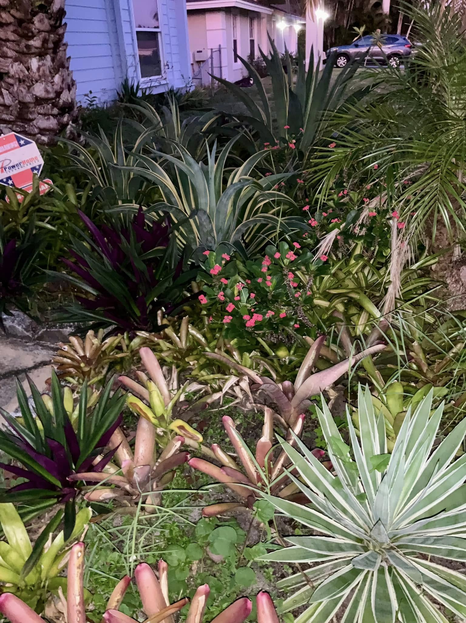
Some say the desert lives beneath Florida’s sidewalks, all stubborn roots and thirsty dreams.
But I know better. I have a green thumb.
Every morning, when the sun yawns awake,
I step into my garden,
feeling the cool hush of earth through grass and memory.
Here, bromeliads blush like shy dancers,
Moses-in-the-Cradle hides purple secrets in folded leaves,
and the heliconias lift their fiery spears as if they were guardians of paradise.
The aloe plant, my brave little healer, pushes up its orange cone of blooms,
a lighthouse against heat and hardship.
Even the cacti, my spined warriors, don’t hiss at me anymore.
They’ve learned I come in peace.
And tucked between all that wild confidence are roses.
The only scented flowers I seem able to coax into happiness.
They are temperamental queens,
but when they perfume the air,
I feel forgiven by everything I’ve ever lost.
This year, though… the heat was merciless.
My flower beds surrendered to weeds
that rose higher than my waist,
a green rebellion laughing at my neglect.
For a moment, just a moment, I wondered if the garden had given up on me.
It looked like a jungle.
My little dachshund refused to go outside, too scared to brave the tall stalks.
But autumn, even in Florida, brings a small exhale.
Cooler mornings. Second chances.
I roll up my sleeves and wage a gentle war by pulling and clearing, and
laying down mulch like a soft blanket over wounds I promised to heal.
In the middle of a one of the flower beds, a pineapple plant, a bromeliad in nature,
unexpected and unruly, has decided to thrive.
That’s the thing about gardens:
They believe in miracles long before we do.
So how does my garden do?
It grows.
It forgives.
It waits.
And every time I step outside,
hands in the dirt, heart in the work,
It reminds me:
Resilience has roots.
And beauty, once planted,
always tries again.
