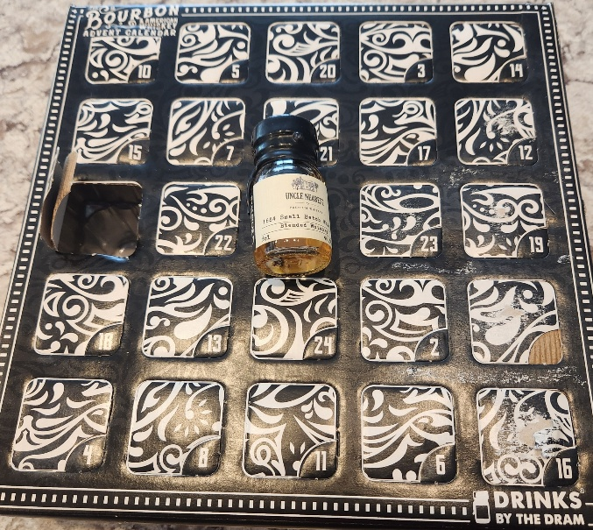
I’ll never admit this to my wife, but I am tired of drinking bourbon. Its all her fault. She gave me a Bourbon Christmas Countdown calendar this year. I may not recover, but I will try.
For twenty-four long days, I was compelled to open a little numbered door in a big box and extract the bourbon of the day, stored conveniently in a small, glass, dram-sized bottle. A dram, I learned, is a “flexible” measure from twenty-five to thirty-five milliliters, if you get the pour in Scotland or Ireland. It’s probably equally flexible in the States if you can find a bartender who knows what a dram is. I can’t actually think of a better place than either Scotland or Ireland to get a dram of whiskey, but I can’t afford the plane fare just to get a drink. A dram, by the way, is smaller than a shot, but enough to get a taste.
So, each day I broke the cute wax seal on the bottle, and poured my dram of whiskey over two or three ice cubes into my fine, lead crystal whiskey glass. Then I let it sit for a bit. As any whiskey expert, a.k.a. a lush, will tell you, the whiskey must “breathe” a bit and combine with the water to “open up.” I am using all these technical whiskey tasting terms because my interest in drinking whiskey is purely scientific. In truth, some nights I was pretty scientific about drinking whiskey; other nights, my impetuous nature overpowered my good judgment, and I took a sip right away.
Like a good scientist, I created a log to record my results, and each entry includes the day, whiskey name, and my scientific assessment of flavor on a scale of one to five stars. Naturally, after savoring the test whiskey, I sampled my usual Woodford Reserve, just as a control, naturally, and not for any other reason, as anyone familiar with the scientific method can tell you, my goal being purely to establish a whiskey baseline. No sloppy science for me. I have my principles. My principles may be flexible, but still, I have them. I keep them in the junk drawer with our old batteries, broken pens, and bent paperclips.
But now, for this time only, you get an exclusive. I’m giving you access to my valuable whiskey imbibing observations. That’s right, I am sharing the findings with you, dear reader.
First, I gave fifteen of the twenty-four whiskeys five stars, or sixty-two percent of the sample. That sounds like a big number because it is. Either, and most likely, I have low standards, or less likely, it was all very good bourbon. There is no telling for sure which case is true, as I possess a singularly unsophisticated palette and uncommonly low standards.
Second, only one whiskey received a single star: a peated whiskey. Peat is basically bog material, composed of decaying plants and other stuff that goes down to the bog to die. Some people in the U.K. still burn it for heat. The barley used to make the whiskey is dried over a peat fire, imparting a smoky flavor. I didn’t like it, as you may have surmised. It tasted like the whiskey had been filtered through a moldy sweat sock stuffed with dead maple leaves, and I had to cleanse my palate with a glass of Woodford Reserve. I think I was supposed to cleanse my palette with crackers or some such, but it is my experiment, and I make the rules.
Third, most of the whiskey names must have been created by marketing departments and focus groups, such as Rabbit Hole, Bulleit, Uncle Nearest, Rebel, Redwood Empire, and James Cree Cattle Ranch. With that last one, I hope they didn’t let the cattle chew on the barley first.
Fourth, my favorite whiskey is either Four Roses or Uncle Nearest. Both were smooth, without the harsh, bitey sensation you normally get with a strong spirit, and had caramel and nutty notes, if that makes any sense. See how I snuck another whiskey taster definition in there? Note is a technical term that translates to 'aroma' or 'flavor,' or maybe 'aroma and flavor.' Notes are defined not musically but with words like carmelly and nutty. I couldn’t be a whiskey reviewer. To me, whiskey smells like whiskey and tastes like whiskey, although I can pretend to understand all the official taster words as well as the next guy.
This concludes my narrative of the very scientific whiskey tasting I conducted, at great personal cost and dedication, on the days leading to Christmas 2025.
None of this will change my go-to whiskey. Had I rated the whiskeys on cost, they might have garnered one star. A fifth of Uncle Nearest costs about $56, and the Four Roses Small Batch about the same. My trusty Woodford Reserve comes in at about $30 a bottle and tastes just fine.
On second thought, I expect I will recover from my whiskey ruination. All this talk of whiskey has made me thirsty, and shouldn’t I benefit from my scientific endeavors? I can see a future where I expand my scientific method to other areas, like barbequed ribs, beer, mac and cheese, and maybe even lobster rolls.

