Stones, Sand, Solstices
Norma Beasley

It was midnight at Kennedy International Airport in New York, and I was over the moon with joy as I buckled up in my window seat on the first transatlantic flight of my life. I was on the first leg of a journey to a Rosicrucian AMORC convention in London and a tour to Stonehenge followed by a visit to the Great Pyramid of Egypt in Cairo. As I peeked out the window at a blackened sky, the only light shown was that of a full moon. I pinched myself to make sure I wasn't dreaming. Next to me sat my best friend Pearl and next to her sat Christine, her 14-year-old granddaughter.
The cabin soon filled with chatty passengers squeezing by one another and stuffing overhead storage bins with carry ons, extra sweaters, reading material and miscellaneous items. After preflight instructions, the cabin lights dimmed and push back began from the gate. Pearl and I held hands as we prayed for a safe flight. Slowly the big bird inched towards its takeoff position while staff scurried to secure overhead bins, glancing left and right making sure passengers were seated upright, trays locked in position, and seat belts buckled. Finally, the jumbo jet reached its takeoff position. A brief pause ensued. Then we began to roll down the runway, picking up speed, the jet engines roaring behind us as we rose into the blackness of night, the wheels retracting into the fuselage. We were temporarily pinned back in our seats. Finally, we turned and headed towards the Atlantic Ocean passing beyond the three-mile limit. I glanced at the moon again. Eventually the roar subsided, and it became a magically smooth quiet ride. We unbuckled, watched the flight path on TV, ate dinner then fell asleep. Destination, Heathrow airport London.

London, home of luminaries Sir Francis Bacon, Robert Fludd and Issac Newton was an excellent venue for the mystical, scientific, and philosophical organization’s convention. Its focus on concepts such as the spiritual significance of giving and receiving, cosmic consciousness, meditation, and spiritual alchemy were subjects dear to my heart. It was the first time I had seen thousands of members from all over the world meet as a body to join hands in sharing insights relative to the mystical arts and science through forums, workshops, presentations, and convocations.
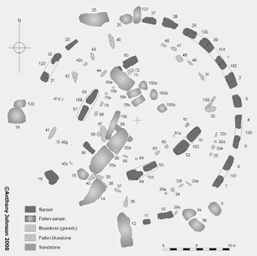
The highlight of my stay in London was a tour to Stonehenge in Wiltshire England—the world-famous prehistoric monument of massive standing stones arranged in concentric circles thousands of years ago on the Salisbury Plain. Stonehenge is estimated to be approximately 5,000 years old. Its sarsen sandstone and blue stones appear to perfectly align with the sun on solstices and equinoxes. No one knows for sure who built the neolithic monument or for what purpose. But most archaeologists agree that the stones mark the changing of seasons. When I reached out to touch the cold stones, its ceremonial, and astronomical significance tugged at my heart strings. I was humbled and honored to “shake hands” with my sisters and brothers from an ancient past. What a privilege to be able to touch these fabled and ancient monsters rising to the sky. To be able to connect with ancient mankind through an almost indestructible inanimate object. Now days, the stones are roped off.
Stone plan of Stonehenge
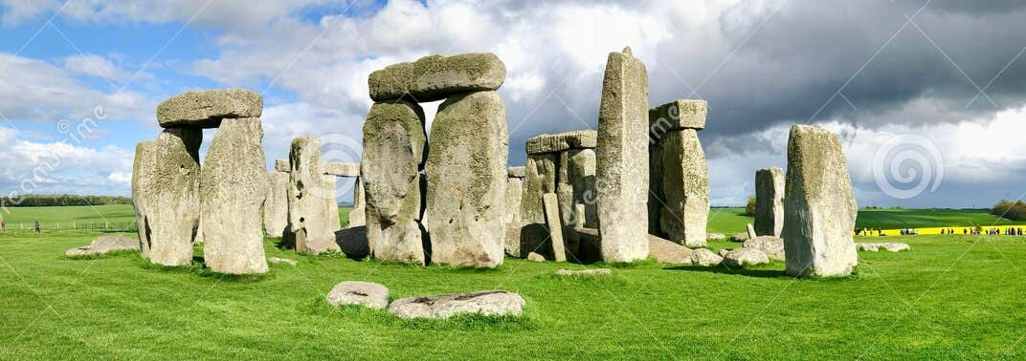
Panoramic view of Stonehenge

Pearl, Christine and I arose the next morning, packed our clothes and headed to Heathrow for the long flight to Cairo, Egypt. Upon our arrival our passports were seized by our guide. My heart jumped up into my throat. But it was for our good. Our last admonition upon leaving New York was to make sure our passport was always secure. In Egypt, US passports are highly valued. Our guide safely stored them relinquishing us of the burden.
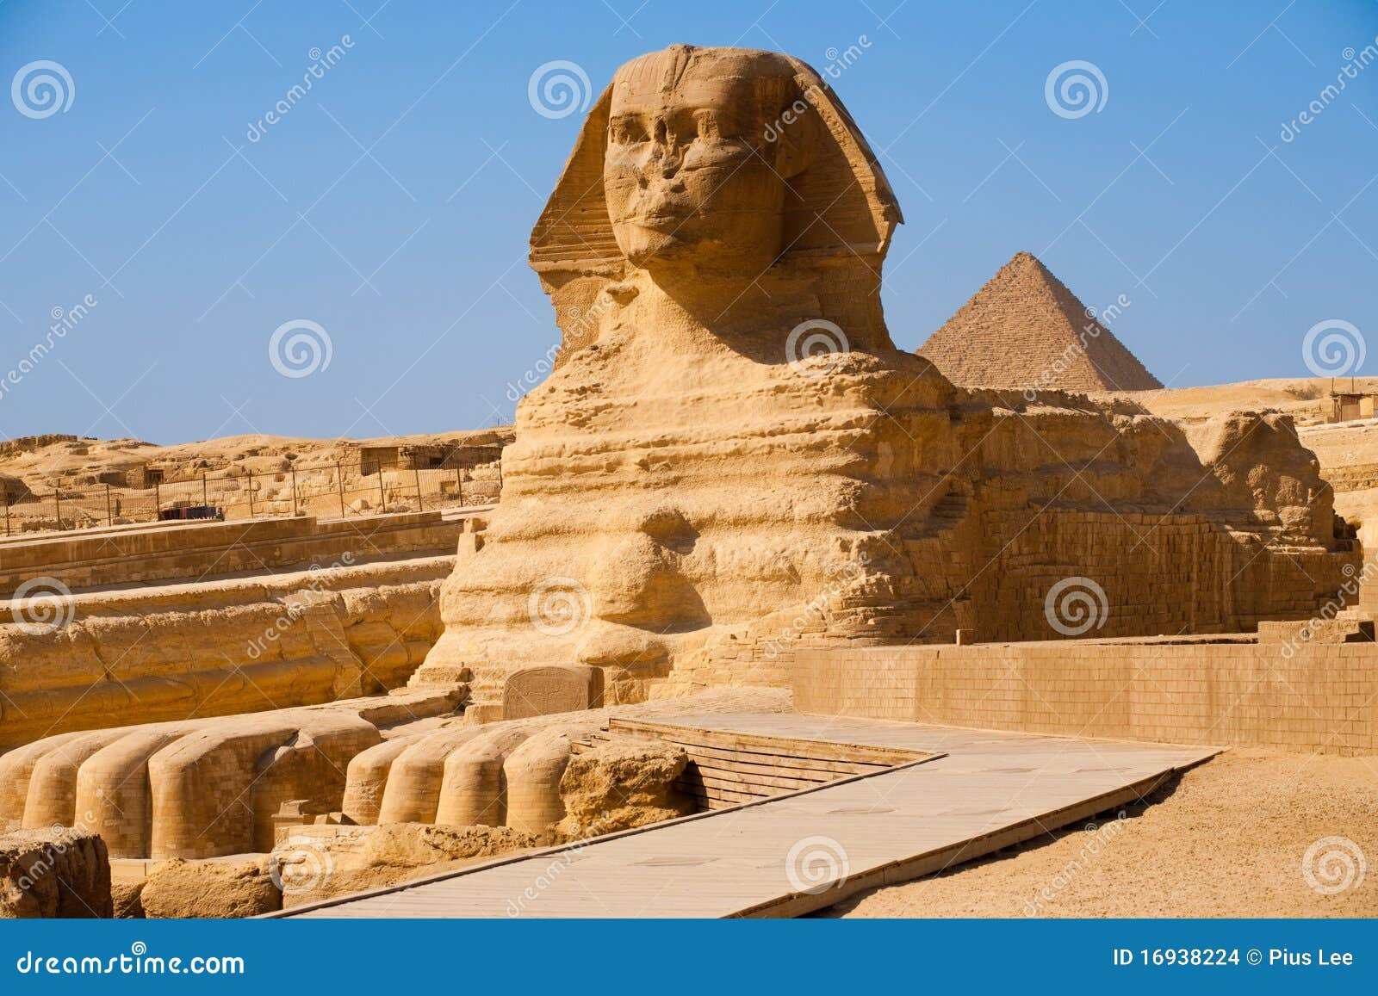

Great Sphinx at Giza

Rising early in the morning for individual tours was a challenge. It wasn't fun to get up at 5:00 AM and set out on our trips. But it was necessary because of the stifling heat of the day. Our
first stop was the great limestone Sphinx of Giza with a lion’s body and a pharaoh’s head. There it sat in all its splendor symbolizing strength and wisdom. The pyramid contains the tomb of Pharaoh Kufu in his granite sarcophagus. Great temples served four purposes. The deceased body was kept safe. It demonstrated the status of the deceased and his family. Retained the deceased place in society. And served as a place where offerings could be brought to the deceased.
The Egyptians observed solstices as well, in particular the winter solstice symbolizing rebirth and the victory of sunlight over darkness. The suns rays aligned with specific sacred areas in temples and tombs. The summer solstice celebrated the power of the sun God Ra. Solstices helped the Egyptians track the year, influencing agricultural cycles and religious rituals. The summer solstices aligned with the rising of the river Nile.
Christine had a wonderful time riding on a camel. Pearl and I didn't have the guts to try it. We also visited underground tombs, and on another occasion, we were able to climb stone steps with a rope as our guard rail into one of the pyramid chambers. “Folks, if you are skittish about continuing the climb, turn around and go back to the entrance NOW. We are at the point of no return, said our guide.” I don’t remember anyone turning around so we began to crawl like a crab on the beach to the queen’s chamber. We were drenched in sweat as if we had just taken a shower. Once inside the chamber, we could stand up. Our surprise was that it was empty! Near the entrance on our decent, two women spotted us and stopped dead in their tracks.
“How was it they asked?” Before we could respond, they took a second look at us and decided the trek wasn’t for them.
We enjoyed cruising on the Nile in a medium size ship and sailing in the feluccas which were small simple sailing ships with distinctive triangular sails. We even had the opportunity to visit a marketplace along the Nile when all the lights went out during a night market excursion. Pearl, Christine and I froze in place fearing the worst. Eventually I purchased a small alabaster vase with figural decoration and inscribed base with pseudo hieroglyphics printed on the bottom of it as a souvenir.
Our last highlight in Egypt was the Egyptian Museum in Cairo. It is the oldest archaeological museum in the middle East housing over 170,000 artifacts. It has the largest collection of Pharaonic antiquities in the world. I marveled at a piece of lace that had lasted thousands of years.

What insights did I glean from this experience you might ask? Upon reflection, I share the following thoughts.
Across ancient civilizations, people acknowledged a power greater than themselves. Skepticism, at least in the way we understand it today, was far less common. Instead, communities sought meaning through the cosmos, interpreting the movements of the moon, stars, and heavens as signs of a larger order. It’s remarkable that more than 5,000 years ago, people recognized a sense of cosmic harmony so deeply that they built enduring monuments to reflect it—structures meant to bridge the earthly and the divine. Their sacred spaces, afterlife beliefs, and devotion to celestialspatterns reveal a worldview guided by what we might now call angelic or divine forces. And even with the limited tools available at the time, they left behind lessons we can still learn from today.

