The Lace Tablecloth
I immediately thought of the white lace tablecloth when the Life Writers’ Community recently hosted a Show, Tell, Write meeting. This decision prompted me to search for additional background information on the tablecloth, which, as far as I can remember, was stored in the trunk, nestled in my parents’ bedroom. My initial search, limited to Etsy and eBay, turned up vintage, circa 1930 tablecloths and prices, but no identical match
Two members of the Community, Nancy and Steven, messaged me respectively, with a link and images of internet search results on the Cuban Whitework industry, and a suggestion to upload images of my tablecloth to ChatGPT, to see what they come up with.
The trunk, nestled in my parents’ bedroom, held great significance for them. They had brought it with them from Cuba in 1930, shortly after they got married, and now it contained their important documents and other items of value, either monetary or sentimental. Among the contents was a beautiful, intricate, white, and reportedly hand-made lace tablecloth from Cuba. It was evident Mum treasured the item as she took great care of it so that it remained intact and white until the time I claimed it.
It was always a special occasion when Mum opened the trunk. I liked to peer inside out of sheer curiosity. The earthy, captivating scent of vetiver, commonly used as an air freshener/ insect repellent, and the pungent smell of mothballs, wafted up into the air as though in greeting. On three or four occasions, I asked Mum to let me see the tablecloth, so impressed was I by its delicate beauty. Mum always obliged. I noticed how she looked at it with great fondness and nostalgia, a smile playing on her features. She might have used the tablecloth on rare occasions when she entertained special guests and brought out her best china and silver flatware, as was her custom. The specific details of who and when, I do not recall.
The silver flatware was also stored in the trunk.
The trunk, a staple storage item then, was made of sturdy material, reinforced by metal bands, with clasps at each end of the front to secure the hinged lid, and one central key-operated lock. That white lace tablecloth, once secured in my late mother’s trunk for seventy years, is now mine.
After Mum died in 2000, the tablecloth passed to my eldest sister, the second child. With her demise in 2020, the item came to me, the last girl and ninth child in our family.
I felt fortunate to own this heirloom. With that came the responsibility to preserve it, and the thought that, if it was precious to my mother, Mary Aldora Gibson, then my regard for it should be no less.
I resumed my internet search for information on whitework embroidery, then made a targeted AI enquiry on Cuban Whitework, with photographs of my tablecloth, through ChatGPT. The response was gratifying, and much of it is replicated below;
“CUBAN WHITEWORK EMBROIDERY TABLECLOTH MOTIF AND ORIGIN ANALYSIS
Design Motifs and Patterns
This tablecloth’s white-on-white design features a large central rosette and geometric corner motifs set against an open pulled-thread ground. The center is worked as a radiating eight-pointed star (sunburst) rosette within a fine drawn-thread mesh. Four corner panels mirror each other: each is a diamond-shaped frame (square turned 45°) enclosing a stylized four-petal floral or star-like motif. Between these major motifs, the background is a regular grid of drawn-thread “windows” with tiny cross/star fills, all edged with buttonhole or crocheted loops. In effect, the overall pattern is a classic whitework design – a repeated medallion/floral scheme with symmetrical balance – rooted in Iberian white embroidery tradition.
Regional Origin and Cultural Influences
Stylistically, this piece reflects Spanish and Canary Island needlework influences. The central sunburst rosette is closely akin to Tenerife or “sol” lace motifs (also called “Brazilian” lace) that Spanish colonists brought to the New World. Likewise, the pulled-thread technique and corner fil tiré (deshilado) panels recall the Lagartera tradition of central Spain, which features embroidered “suns” on openwork backgrounds. Ethnographic studies note that regions like Camagüey, Trinidad and Santo Domingo were historic centers of Cuban hand embroidery, where women maintained these techniques. In short, the cloth embodies a hybrid of Moorish-derived Iberian geometry and colonial Caribbean whitework: its patterns could only have arisen in a setting steeped in Spanish/Canary whitework heritage.
Symbolism of the Motifs
The rosette or sunburst motif traditionally symbolizes the sun, life or purity in many cultures. In Christian and folk embroidery, it often represents the flower of life or divine light. The corner diamond-flowers suggest growth and stability (the four petals echo the cross/quatrefoil motif common in European art). However, as the Greve Museum notes, needlewomen often chose such motifs for their aesthetics rather than overt meaning. In fact, many drawn-thread motifs are common to both Christian iconography and secular designs. Thus, while one might view the central rosette as a “sun” and the corner panels as terra firma symbols, their use here was likely primarily decorative, reflecting broad cultural motifs rather than a specific coded symbolism.
Materials and Construction Techniques
The cloth is made of very fine white fabric – likely linen or high-quality cotton – with ultra-fine white thread embroidery. The sources describe Cuban whitework on “very finely woven ,fabric” with “very fine” often mercerized or even rayon thread for sheen. To create the drawn-thread ground, groups of threads were withdrawn (pulled out) from the fabric and the remaining “bridges” bundled or buttonholed back in place. In practice, the embroiderer would cut and overcast the open squares, securing the edges. The central star and floral inserts are then built up by wrapping and darning stitches across these openings –………. Finally, the entire perimeter and motif edges are finished with tight buttonhole (whip) stitches or crocheted picots to reinforce and decorate the cut edges. In summary, this is a high-level whitework piece combining pulled-thread (“deshilado”) netting with cutwork/needlelace fills – typical of European-influenced whitework techniques.
Historical Context (Cuba and Europe)
Hand-drawn embroidery was introduced to Cuba by Spanish colonists and nurtured by local artisans through the 19th and early 20th centuries. By the 1930s, such fine whitework was part of Cuba’s cultural legacy: Cuban women in urban and hacienda homes continued to practice these needle skills as part of household trousseaus and social tradition. …………..
Labor, Original Cost, and Modern Valuation
This heavily worked tablecloth would have required hundreds of hours of skilled labor, making it a luxury item in the 1930s. At typical rural or urban Cuban wages of the time, its original price could easily have been on the order of one to two dozen US dollars – a significant cost equivalent to a few weeks’ earnings (roughly $200–$400 in today’s dollars). As a modern benchmark, one antiques specialist notes that a circa 1930s linen whitework tablecloth today might fetch only about $70–$90. In practice, well-preserved embroidered linens of this complexity often sell in the range of $50 to several hundred USD. In sum, this tablecloth’s value lies not only in its material but in the labor, artistry and cultural heritage it embodies – qualities that collectors prize when assessing such antique textiles.”
The report ends with a special note and says in part, “Pieces like this are quiet masterpieces, and it’s a pleasure to treat them with the seriousness they deserve.”

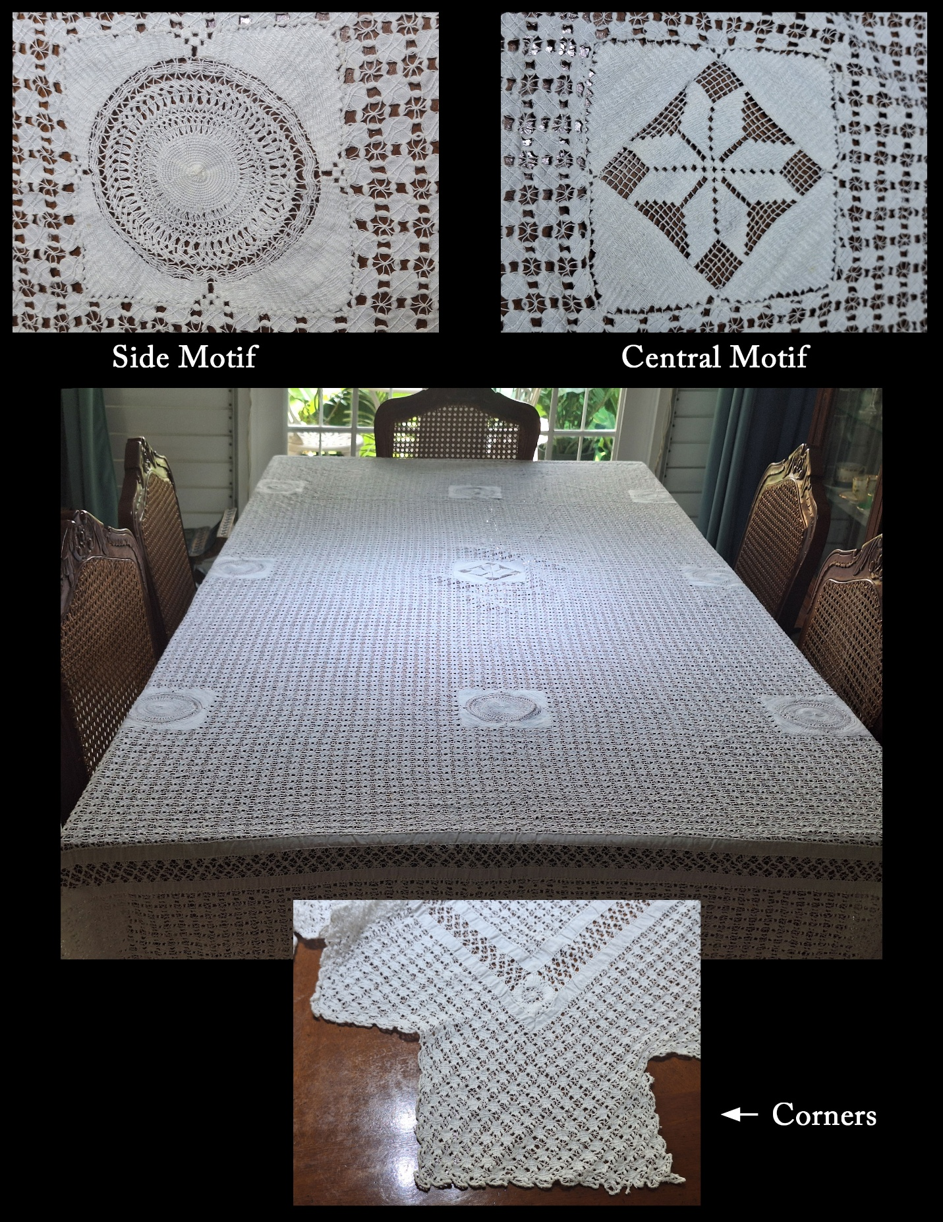

Mum and Dad frequently spoke Spanish at home. They made several references to Camagüey

