Ten Years of Age - Learning to Drive A Human-Body Automobile
This learning experience taught me how to drive through life with little or no fear.
Our prompt “First Driving Lesson Experience,” triggered a memory. It was 1940, I was ten years old and had to learn to drive my ten-year-old body, sometimes carrying a trumpet case and books, three miles, five days a week, September to June to school. To do this, I imagined myself to be a human-body automobile traveling alongside huge metal vehicles that traveled on four-lanes of Colerain Avenue. These are those driving lessons.
“But Daddy, it’s miles to school.”
“Only about three miles.” My Father joked.
“Stop, I’m scared. Look at all those trucks, buses, cars, and streetcars. How can I walk three miles on this narrow sidewalk to and from school alongside this busy four-lane road?”
“Mother and I will walk to and from school with you this week. You’ll feel better.”
Streetcars 1940 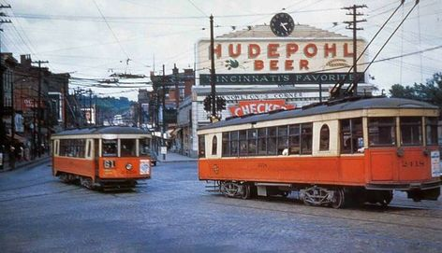
“Jackie, I well remember how you, age four, and Spot dug a hole under our backyard fence and fearlessly walked a mile to my grocery store.”
“But I was little and didn’t know better.”
This six-year episode of my life began in 1939. I was seven. My parents and I moved to Miami, Florida. The Cincinnati snowy wintry weather did not agree with my father’s health. Miami’s year-round warm, clean salt air was perfect for him. Mother opened her own restaurant, Melba’s Grill. Dad worked laying carpet for an old family friend. I walked three blocks from our house to school. Life was so simple and great.
December 7, 194l, our happy existence drastically changed. The Japanese bombed the United States’s Pearl Harbor. On December 11, our Congress joined World War II.
2. We had to move back to Cincinnati to care for my father’s elderly parents. Daddy’s younger brother, Pete, and older sister, Marie, were caring for them. Pete joined the Army. Marie's position at Western Union Telegraph was placed on round-the-clock government alert.
My grandparents house was three miles, not three blocks, from my school, on a busy, noisy four-lane road heavily trafficked with streetcars, trucks and many, many cars expelling tons of dust, dirt and black soot-like smoke.
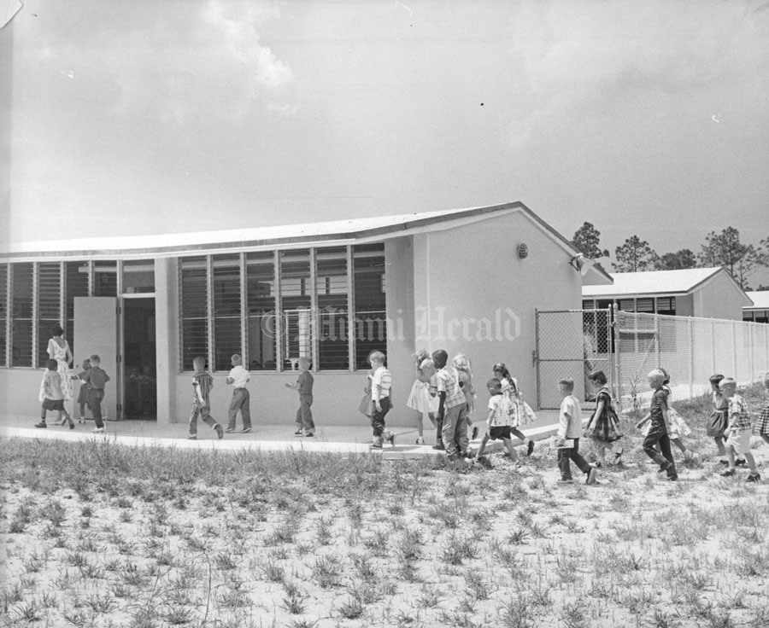
FROM THIS: One story Miami Florida Shadowlawn School, Kindergarten to Sixth grade

TO THIS!!!!!
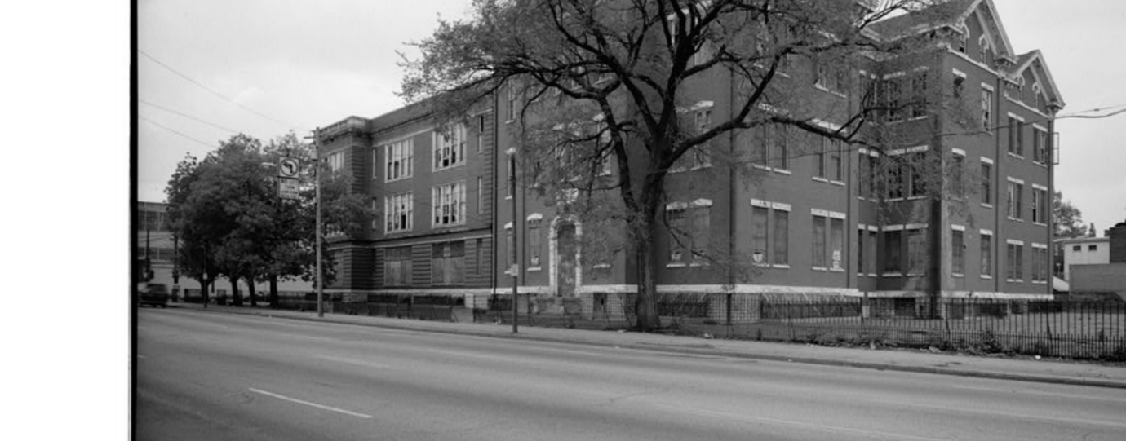 A three story, three building Camp Washington School, Cincinnati, Ohio, Kindergarten-8th Grade
The first day of school, both parents took off work to register me.
“We’re taking a streetcar today, but most days you’ll walk halfway to school with your mother to her work and the other half by yourself as we walked last week.”
3. We walked to the Police Station. Once there, Dad continued, “This is the best place to cross this busy street. See the Streetcar Stop across the street. From here, you can look to the right down over the hill and easily see the streetcar coming uphill. On rainy days you can stay dry by standing under this cover at the Station. When you see your streetcar, wave. The conductor, I’m sure, will wait for you to cross the street and board. Look, here’s ours.”
Dad waved and sure enough the streetcar stopped.
“Stop!” Dad bellowed as he stretched his arm in front of us. “Be sure to look both ways and make certain no cars are coming before you cross.”
The Conductor waited for us. We crossed and boarded the streetcar.
I giggled breathing a deep sigh of relief “This is sort of scary. Hope I can do it alone.”
Daddy and Mother sensed my anxiety. “We know this is quite a change from Miami. You can do it. Think, another adventure.”
“Yeah, sure Dad, easy for you to say,” I mumbled to myself.
This was fun. We bounced and swayed back and forth as the streetcar rumbled its metal wheels over the railroad-like tracts. As the conductor pulled a chain up and down, the metal bell clanged.
As we passed Mother’s factory building, she blissfully spoke, “Jackie, we can walk together this far each morning on your walks to school. After school, you can come here, wait inside with me, and walk the rest of the way home together.”
The streetcar continued past the two long blocks of factories, the Restaurant Bars. Then a weird smell engulfed our nostrils. “Phew! What’s that awful smell?
“That’s the slaughterhouses, pigs and lambs on the right, where Uncle Pete worked. On the left, the cattle slaughterhouse, where Uncle Chic worked. I’ll tell you about that later.”
“Ooh, what is that yummy smell?”
“A factory where they slice white potatoes, fry them and Walla, the Potato Chips we eat.” Mom responded.
Thinking to myself, Wow! These are all of the weird things my human-body automobile will meet every day.
4. Daddy then showed me how to reach up and pull a black ropelike cord that rang a bell up front to signaled the conductor to stop at the next corner, Hopple Street.
As we disembarked the streetcar, our nostrils were again filled this time with a sweet succulent smell of cinnamon, nutmeg, mingled with tomatoes.
“Ooh, what is that?” I cried.
“The best chili in Cincy.” My parents simultaneously replied.
As we passed around the Chili Parlor Restaurant corner, the odor changed.
“Wow!” I cried, “I smell onions and hamburger cooking. Oh, look a hamburger store.”
After I was registered, (another amazing story) we had a chili hotdog and my father advised me that each day I would have a Nickle to buy either a hamburger or chili hotdog to spend for an afterschool snack.
The next day, I was on my own. I walked with Mother as far as her job, then, on my own, my Human Body Automobile kicked in as I successfully maneuvered it along the concrete sidewalk alongside the metal vehicles on Colerain Avenue and now physically meeting the sights, sounds and smells I experienced on the streetcar yesterday.
After school, I hurried out of school, two nickels clutched tightly in my small fist (Dad said I could have a double treat.) I hurried first to the White Castle, ordered one hamburger with everything and then onto…….the chili parlor on the corner. Opening the door to the store, I walked up to the counter, looked the man behind the counter in the eye and said,
“Could I have a hotdog with chili, onions, and grated cheese on it?”
“CHILI HOTDOG LOADED!” the man bellowed, scaring the devil out of me. “That will be five cents, young lady.”
Shortly, it was handed to me, wrapped and placed in a bag. I left, walked surrounded by Human-body Automobile for what seemed forever to my mother’s factory. I entered, found my mother, grined bellowed, “I made it.”
5. Mentally collapsing, I quietly sat, ate my rewards for the day while Mother worked. (I did save half of each for my sweet, dear Mom.
Yes, my Human-body Automobile that I so well learned to drive those six years in Camp Washington continued to serve me well for eighty-plus more years.
Which One????Maybe one for me and one for my Human-body Automobile
