Eddie’s King Midget
He was a white-shirt kind of guy. Always, always in a crisp, clean white shirt. Long-sleeved too for that sharp polished kind of look that you expected of a banker you trusted your money to. That was Uncle Eddie. Dressed down for informal gatherings, maybe the shirt would morph to a short-sleeved one. But that was as far as I ever saw him go casual. Yup, he was a no digging in a garden, dirty hands sort of fellow. But he always had a sparkle in his eye and a ready quip to pull out of his verbal back pocket for you.
Maybe all that was veneer. A coating over his inner rebel that yearned to get out. I think I saw the inner man when Dad came home and announced that Eddie had just gotten a King Midget car. I was a little kid at the time, but it seemed that every magazine I picked up had an ad buried in the back touting these miniature cars. Tiny little things with an open top, air-cooled lawnmower engine and tires that looked like they came from a wheelbarrow. I had to see it and Dad’s curiosity for it yielded an immediate ride for us to Eddie’s for an inspection.
These cars were actually sold in a mail order fashion with no dealerships. Eddie saw the ad, placed his order and waited for a truck to deliver a giant box to his house. Now, Uncle was a Buick and Oldsmobile sort of driver. Hugh tanks of cars with massive doors, hoods I couldn’t even see over, and trunks that could house a small family. It was totally baffling to us that a man accustomed to piloting land-barges with V-8 engines and tail fins would get a micro-car. Of course, getting The Box and turning it into a car was totally beyond Eddie. No problem though. Son-in-law Pat lived just up the block and was super handy with tools. He had the little car assembled when we arrived and we swarmed over it.
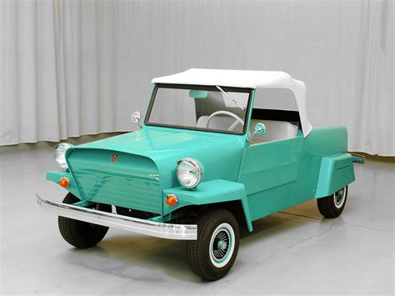
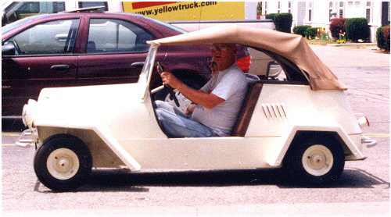
It was about the cutest toy I ever saw and immediately fell in love with it. It was like a go-cart with a body attached, before go-carts were even invented. With only room for two people, you almost sat on the ground. Yes, it had everything needed in the late 1950’s to make it street legal. Lights, horn, turn signals were all there, but I wasn’t sure that a tiny car like that could even be seen in traffic. The starter was manual; very manual. One would lift the back lid and pull on a rope attached to a large lawn mower engine. The transmission was a series of belts and pulleys like scooters of the time. Just push down on the accelerator and eventually the car sort of oozed forward.
Faded memories of family stories indicated that Eddie was brave enough to drive it to the Jersey Shore one summer. That adventure would certainly have taken most of a day to achieve. Quite an unlikely feat for my white-shirt banker uncle, but it resulted in another great story.

