Copernicus
Judy Fink

In 2012 my daughter Lisa’s family met us for a week’s stay at SeaWorld near Orlando, Florida. The grandkids, Brooke, twelve, and Joey, ten years old at the time, wanted to visit Discovery Cove to snorkel and later get in the water to swim with a dolphin. I was the only adult to volunteer to go with them.
Kelly was our guide for the encounter. She was a pretty girl in her late twenties with a long dark ponytail and light shaded sunglasses. She wore a four-inch silver whistle on a lanyard around her neck and gave instructions to the group on how to interact with the dolphin so everyone would be safe. We all carefully walked down the sloped sides of the large pool to enter the chest-high water. She then blew the high-pitched whistle which was at an octave we humans could barely hear. Gliding smoothly through the water a large grey dorsal fin could be seen heading our way. Here came Copernicus, a ten-foot-long, shiny grey, 600-pound dolphin. He was large and beautiful. We stroked his huge head, careful to avoid the blowhole. Kelly then had him roll over so we could stroke his soft white underbelly.
In this large expanse of water, several other dolphin encounters were taking place. Copernicus saw his “girlfriend” yonder and decided to pay her a visit. We were left standing and watching as he took off across the water. Kelly smiled and said, “Copernicus wants to see his girlfriend Shena and a 600-pound dolphin can go anywhere it wants, whenever it wants so we’ll just have to wait. Thankfully he came back after a short time. Kelly whistled again and we watched in awe as he made several acrobatic leaps into the air, spinning and diving with grace and speed splashing us each time his long body hit the water, we loved it.
The best part came when we each got to go for a ride holding onto his dorsal fin as he sliced through the water. He propelled us with the strength of his massive tail fins. The water swooshed under our legs as he sped up. You could feel the power as he moved through the water with ease, barely noticing the human hanging on for dear life.
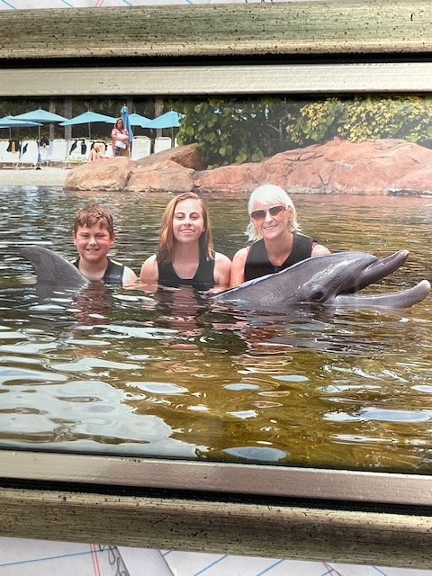
The finale came as he swam up to us and put his nose right up to our face. We held his head and kissed his nose goodbye as pictures were taken. What a thrilling moment and memory for all three of us.

